
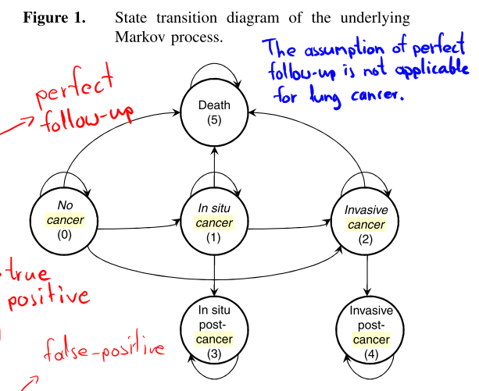
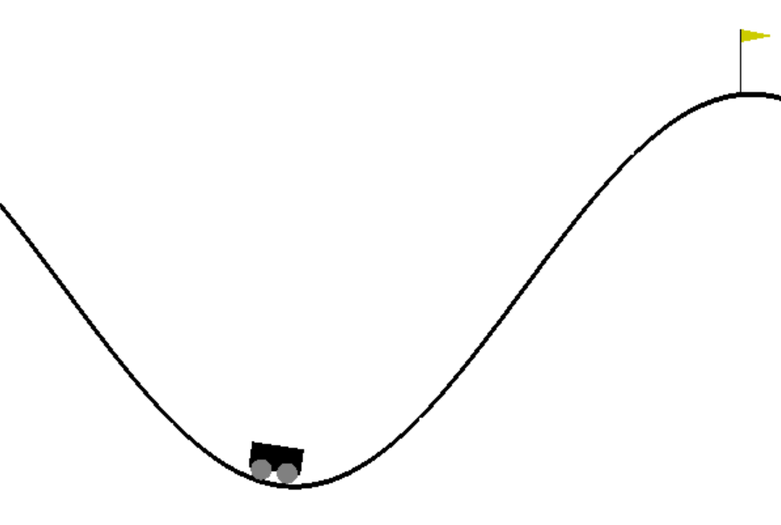
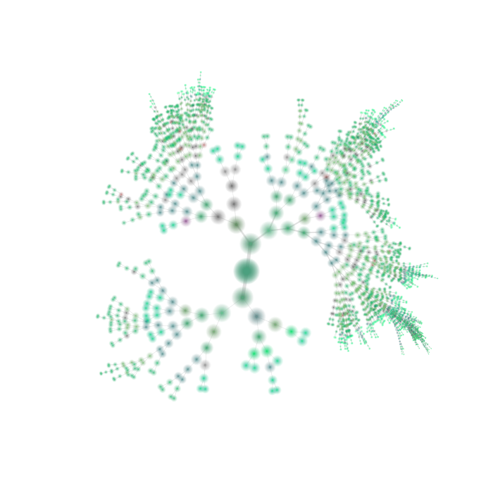
ASEN 6519-007 Spring 2020
Decision Making under Uncertainty
TTh 10-11:15am Aerospace Engineering Sciences 114
Instructor: Zachary Sunberg (zachary.sunberg@colorado.edu)
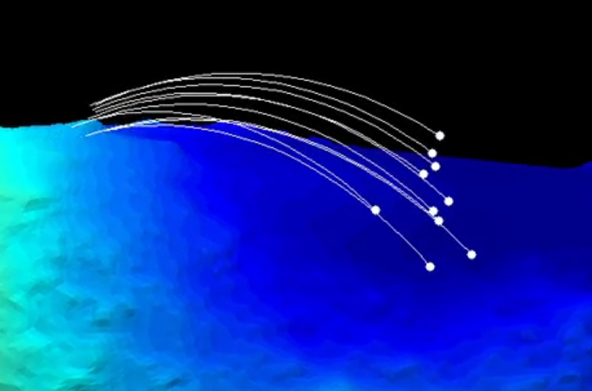
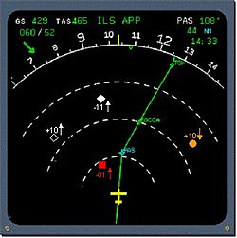

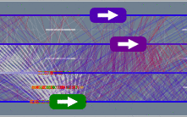

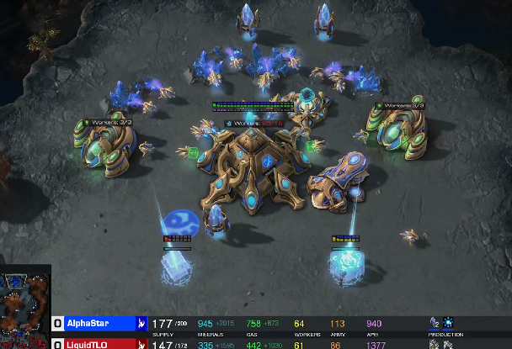

Our uncertain world is a dangerous and difficult place for autonomous systems. Self driving cars interact with unpredictable humans; drones must avoid sporadically moving aircraft; smart buildings and infrastructure need to cope with uncertain future demands; medical decision support tools must manage inaccurate tests while adapting to different patients; and space probes need to explore unknown environments.

Fortunately, there are systematic ways for modeling this uncertainty and making decisions in uncertain environments. This course will focus on those methods, using the Markov decision process (MDP) and partially observable Markov decision process (POMDP) frameworks for controlling systems with uncertainty and even managing the uncertainty itself. For students who have taken ASEN 5044 or ASEN 6519 Advanced state estimation, this course will complement that knowledge, exploring methods for control of uncertain systems rather than estimation only.

Course topics will include:
- Modeling with Dynamic Bayesian networks
- An introduction to game theory
- MDPs and POMDPs
- Exact and approximate dynamic programming
- Traditional reinforcement learning and intro to deep reinforcement learning
- Offline (PO)MDP methods (alpha vectors, point-based backup, factorization)
- Online (PO)MDP methods (Monte Carlo tree search, determinized sparse tree search)
Assignments will include:
- Final project where students can apply material to their research
- Programming assignments (formulating problems and implementing solutions using the Julia programming language)
Prerequisites:
- Strong understanding of applied probability (ASEN 5044 or equivalent)
- Comfort using a high level programming language to complete projects independently

